- Pressure Relief Valve
Application : Pressure Relief Valve (P.R.V.) is a mechanical safety device used for relief of excessive pressure build up and Transformer, Top Changer, Pressure Tanks & Pressure Lines for indoor & outdoor application. Suitable for repeated operation as compared to Conventional Explosion Vent which is for single use.
Working : The release Port is sealed by a Stainless-Steel Diaphragm resting on an “O” Ring. Heavy Duty Spring Set keeps the port closed in normal condition. As soon as the pressure exceeds the pre determined safe limit due to any reason like change in temperature, formation of vapor etc. The diaphragm gets lifted from the seat. This exposes the tank pressure to a greater area. Resulting to sudden increase of force. Thus instantaneously opening of release port and a lowing vapor, gas & liquid to flow out of tank. Resulting to fa l of pressure. The diaphragm restores its normal position as soon as pressure drops below the set limit and is ready for second jump. Spring retainer prevents the dislocation of spring during repeated operation. The lift of diaphragm also operates the Limit Switch (Double Pole/ Double Throw type) & Visual Indicator (Flag) by help of Rod. Engineered for rugged use & long life each P.R.V. is checked for its operational condition individua ly. It is important to note that depending upon the tank fluid different “O” Ring material is suggested.
Note : - Our standard product feature is
1). PRV with Nitrile Rubber Gasket.
2). Limit Switch confirms to weather protection IP-67 and is with ¾” 16 T.P.I. (B.S.C.) PVC Cable Gland.

Model :
1. Pressure Relief Valve with Switches
Model:
DP-1
Page :
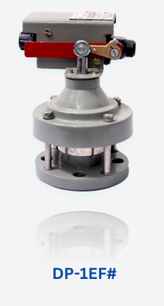
Model | Port Size | No. of Holes | Bolt Size / Hole Size | P.C.D
DP-1 | 1" | 4 | M08 / 10 mm. Ø | 85 mm
Models Available
Where: Ø = Size of Release Port (6", 3", 1")
# = No. of Electrical Contacts [(1 for 1 N.O. & 1 N.C.) & (2 for 2 N.O. & 2 N.C.)]
S = With Shroud / Oil Direction Cap
P = Number of Pins
C = Number of Cable Cor

Features | Model
Without Electrical Contact & Visual Indicator | DP-Ø
With Electrical Contact & Visual Indicator | DP-ØEF#
With Shroud/ Oil Collection Cap | DP-ØEF#S
With Plug and Socket Type Limit Switch Connection | DP-ØEF#P
With Shroud /Oil Collection Cap & Plug and Socket Connection | DP-ØEF#SP
With Shroud /Oil Collection Cap & Plug and Socket Connection & Cable | DP-ØEF#SPC

DP-3
Page :
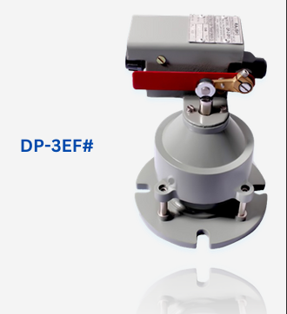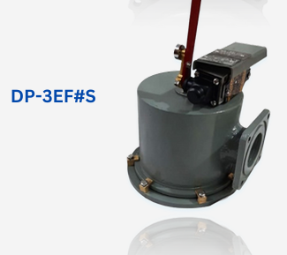
Model | Port Size | No. of Holes | Bolt Size / Hole Size | P.C.D
DP-3 | 3" | 4 | M10 / 12 mm. Ø | 125 mm
Models Available
Where: Ø = Size of Release Port (6", 3", 1")
# = No. of Electrical Contacts [(1 for 1 N.O. & 1 N.C.) & (2 for 2 N.O. & 2 N.C.)]
S = With Shroud / Oil Direction Cap
P = Number of Pins
C = Number of Cable Cor

Features | Model
Without Electrical Contact & Visual Indicator | DP-Ø
With Electrical Contact & Visual Indicator | DP-ØEF#
With Shroud/ Oil Collection Cap | DP-ØEF#S
With Plug and Socket Type Limit Switch Connection | DP-ØEF#P
With Shroud /Oil Collection Cap & Plug and Socket Connection | DP-ØEF#SP
With Shroud /Oil Collection Cap & Plug and Socket Connection & Cable | DP-ØEF#SPC

DP-6
Page:
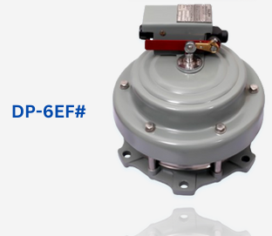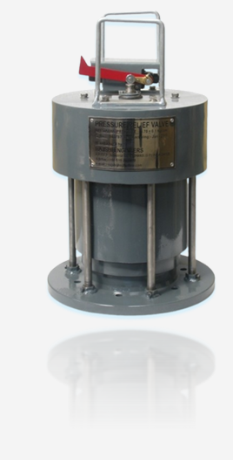

Model | Port Size | No. of Holes | Bolt Size / Hole Size | P.C.D
DP-6 | 6" | 6 | M12 / 14 mm. Ø | 235 mm
Models Available
Where: Ø = Size of Release Port (6", 3", 1")
# = No. of Electrical Contacts [(1 for 1 N.O. & 1 N.C.) & (2 for 2 N.O. & 2 N.C.)]
S = With Shroud / Oil Direction Cap
P = Number of Pins
C = Number of Cable Cor

Features | Model
Without Electrical Contact & Visual Indicator | DP-Ø
With Electrical Contact & Visual Indicator | DP-ØEF#
With Shroud/ Oil Collection Cap | DP-ØEF#S
With Plug and Socket Type Limit Switch Connection | DP-ØEF#P
With Shroud /Oil Collection Cap & Plug and Socket Connection | DP-ØEF#SP
With Shroud /Oil Collection Cap & Plug and Socket Connection & Cable | DP-ØEF#SPC
2. Threaded Pressure Relief Valve
Application : Pressure Relief Valve (P.R.V.) is a safety device to be used in Transformer, Pressure Tanks & Pressure Lines for indoor & outdoor application. Suitable for repeated operation as compared to Conventional Explosion Vent which is for single use. It is compact, highly reliable and particularly designed to be used on O.L.T.C., Transformers, & similar equipment’s / tank with non-corrosive liquid.

Features : Spring Safety Valve completely made of Brass /Aluminium, compact, highly reliable and particularly useful for use in transformer & tanks containing non corrosive liquid even in extreme outdoor condition Reliable Operating Pressure from 20 to 100 KPa. (0.20 to 1.00 kg/cm sq.) Positive Resealing Pressure. • Operating Temperature: 0 to 100° C (of tank liquid). Sealing is with Nitrile Rubber Gasket. Valve Resetting Automatic. Suitable for repeated use. Protective Rain Guard Cap directs the Oil Spillage downwards. Flat Mounting Gasket can be provided if required. Depending upon nature of Tank Fluid we can supply with Viton Gaskets and “O” Ring. PRV at different Cracking Pressure (higher/lower) can be supplied as per your request. Normally we supply in Natural Finish. However, if required by customer we can supply with Ni-Cr plated or suitably painted.
Note :
Each of these models have the following features :
• These can be used as an Oil Filling Cap.
• Mounting position preferably at the tank cover or topside is to be provided with leak proof welded suitably threaded boss having matching threads and tightened by help of Teflon Tape / Sealing Liquid.

Other Details :
These are available in two different sizes
1). Small Size PRV
2). Medium Size PRV
THREADED SMALL SIZE PRV :
These are available only in brass.

Table 1
Parameter 2 3 4
Thread Nomenclature (Ø) 2 3 4
Size of Mounting Thread
British (B/N) 1/4" 3/8" 1/2"
Metric M12 M16 M20
Old Model TS-04 TS-03 TS-04
Passage Area (Appx.) (mm/sq) 30 70 125
Body (A/F) in mm "B" (B.S.P. Thread) 18 22 30
Body (A/F) in mm "N" (N.P.T. Thread) 16 18 24
Body (A/F) in mm "M" (Metric Thread) 18 24 30
Total Length (±) 10 mm (Suit to Assembly) 40 45 55

Table 2
Model Nomenclature Model 1/4" BSP 3/8" BSP
Plain BTØ BB2
With Stainless Steel Pull Ring BTØR BN2R
With Cap (Rain Guard) BTØC BB2P
With Cap (Rain Guard) and Pull Ring BTØCR BB3SR
With Cap (Rain Guard) Riveted / Screwed BTØCS BB2SS
With Visual Indicator (Flag) BTØF BB3F

Where :
- T - Type of thread (B - BSP, N – NPT, M - Metric)
- Ø - Thread Nomenclature: For B.S.P. & N.P.T. Thread (2-1/4", 3-3/8", 4-1/2")
For Metric Thread – Thread Size e.g. M12
- C - Cap (Rain Guard) (P - Plastic, S - Stainless Steel, B - Brass)

Note :
Our all models have option of availability in Natural Finish / Nickel Plated.
Page :
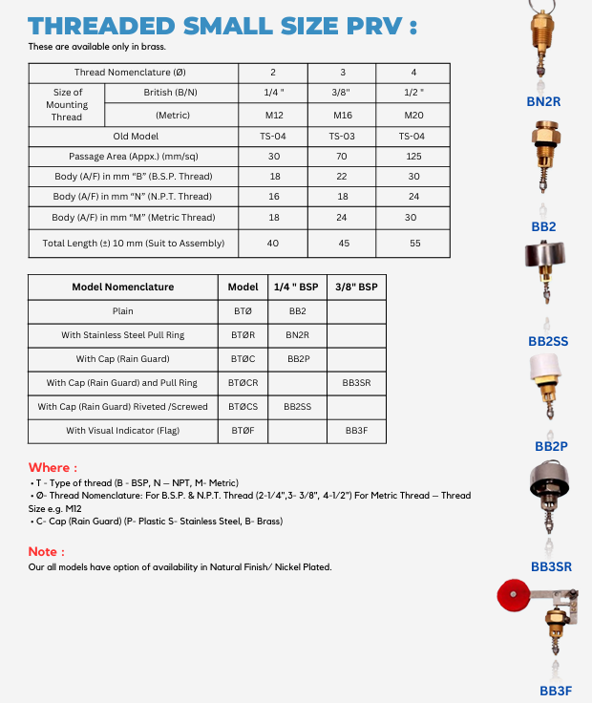
Isme note hata na hai
THREADED MEDIUM SIZE PRV :
THREADED MEDIUM SIZE PRV :

Table 1
Parameter 4 6 8 10
Thread Nomenclature (Ø) 4 6 8 10
Size of Mounting Thread
British (B/N) 1/2" 3/4" 1" 11/4"
Metric NA M26 M36 M42
Old Model T-05 T-06 G-1 G1.25
Passage Area (Appx.) (mm/sq) 125 250 400 800
Body (A/F) in mm "B" (B.S.P. Thread) 30 36 40 46
Body (A/F) in mm "N" (N.P.T. Thread) 24 30 36 40
Body (A/F) in mm "M" (Metric Thread) 30 36 45 56
Total Length (±) 10 mm (Suit to Assembly) 55 55 55 70

Table 2
Model Nomenclature Model 1/2" 3/4" 1"
Plain #TØ SB8
With Stainless Steel Pull Ring #TØR
With Cap (Rain Guard) #TØC BB8P / AB8P
With Cap (Rain Guard) and Pull Ring #TØCR
With Cap (Rain Guard) Riveted / Screwed #TØCS SB4SS
With Visual Indicator (Flag) #TØF
With Oil Collection Bend #TØO BB6O

Where :
- - Material of the body (A - Aluminium, B - Brass, S - Stainless Steel)
- T - Type of Thread (B - BSP, N – NPT, M - Metric)
- Ø - Thread Nomenclature:
  - For B.S.P. & N.P.T. Thread (Ø 3/4", 8 - 1", 10 - 1.25")
  - For Metric Thread – Thread Size e.g. M26
- C - Cap (Rain Guard) (P - Plastic, S - Stainless Steel)
Page :
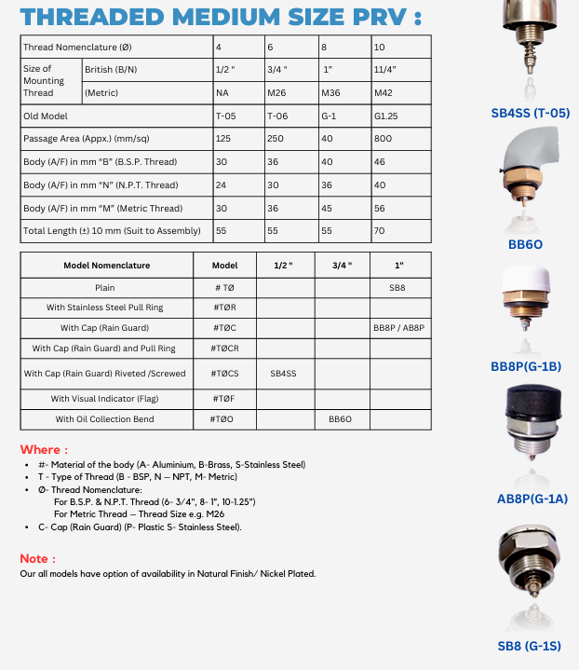
Isme Note hatana hai

3. Flange Pressure Relief Valve

FLANGE PRV :
These PRV are mounted directly on holes provided on Tank

Other Details:
Parameter 1" 1.25" 1.5" 1.75" 2"
Model "P Ø" P-25 P-32 P-38 P-40 P-50 / P-2
Passage Area (Appx.) (mm/sq) 500 800 1000 1500 2000
Number of Holes 2 2 2 3 4
Mounting Hole Diameter 8 8 10 10 12
Total Length (±) 20% (Suit to Assembly) 55 65 80 90 100

Details Nomenclature Table
Details Nomenclature Model
Basic Nomenclature FMP-Ø
With Stainless Steel Pull Ring FMP-ØR
With Cap (Rain Guard) FMP-ØC
With Cap and Stainless-Steel Pull Ring FMP-ØCR

Where :
- F - Finish (N - Natural, C – Cr Plated, P - Painted)
- M - Material of the body (A - Aluminium, B - Brass, I - Mild Steel / Cast Iron, S - Stainless Steel)
- Ø - Port Diameter (mm)
- C - Cap (Rain Guard) (P - Plastic, S - Stainless Steel)
- R - Stainless Steel Pull Ring

Models Shown:
- CP-50 / CNP-2
- PIP-38
- PIP-32
- PIP-25S
- NAP-25S
- CUSTOM MADE
- PAP-25P

Note :
(If needed, you can add standard note)
Our all models have option of availability in Natural Finish / Nickel Plated.

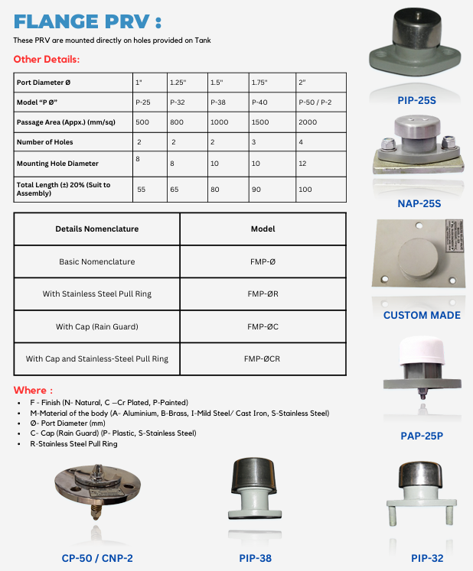

- Oil Level Indicator
Application : Oil level gauge are designed for general industrial use for level monitoring of tanks and similar vessels.

Working :
• Easy to fit these oil Level Gauge gives a clear visibility from distance due to refractive property.
• Depending upon nature of liquid, seal ensures Leak Proof Assembly.

1.Vertical Oil Level Indicator
Application : Oil level gauge are designed for general industrial use for level monitoring of Hermatically Sealed Transformer and tanks and similar vessels.

Working :
• Easy to fit Oil Level Gauge gives a clear visibility from distance due to refractive property.
• Compatible rubber seal ensures Leak Proof Assembly. Features : • UV Protected Polycarbonate Clear window.
• Nitrophyl Float suitable for use in transformer oil.
• Working Temperature- -40 to 120 ⁰C
Mounting Options

Thread Mounting (Vertical)
Mounting Thread | G-1" (1-BSP) | G-1½" (1.5-BSP) | G-2" (2-BSP)
Brass (B) | BB-80*L | BB-120*L | BB-240*L
Aluminium (A) | AB-80L | N/A | N/A

Flange Mounting (Normal)
Model: P-250*L (Body: Aluminium)
Model: BG-1FCL (Flange Mounting)
Model: BG-1FL
2.Threaded Oil Level Indicator
Model: 502 series - Thread Mounting Oil level indicator
• Available in Brass and Aluminium.
• Float Ba l give the clear of Oil level.
• Available in 1“ and 1 (1)/(2)” Mounting.
3.Prismatic Oil Level Indicator
Model:Prismatic-
Available in Polycarbonate and Acrylic Material .
• Different size are available according to customer need .
4.Tubular Oil Level Indicator
Application : Tubular oil level gauge are designed for general industrial use for level monitoring of tanks and similar vessels.

Working :
Easy to fit these Tubular 0il Level Gauge gives a clear visibility from distance due to refractive property.
Float provided helps to know the Liquid Level from distant.
Depending upon nature of liquid, rubber seal ensures Leak Proof Assembly.

Model (TOLG***) :
Different Models are:
ATOLG***- This model has the feature of tightening its bolt from back. This makes it Anti Theft.
BTOLG***-This model has the feature of tightening its Bolt from front.
Where : *** is the PCD of the mounting holes in mm.

- Nitrogen Gas Monitoring System
Application : Used in Transformer or other sealed tank while Storing / Transportation to provide constant Nitrogen (N2) / Inert Gas / Dry Air pressure so as not to alow atmospheric air & moisture to enter Tank.
Working : Gas regulator is used to automatica ly maintain a positive pressure of 0.05 to 0.50 kg / cm. sq. or as desired (pre information necessary) inside the connected tank by help of attached High Pressure gas cylinder In case pressure fa ls below set pressure(or as set) due to leakage or temperature variation, regulator automatica ly a lows required additional gas to flow from the attached High-Pressure gas cylinder This builds up the required pressure. Double Stage regulation beside minimizes the risk also increases the flow rate thus the efficiency of system. To know the inlet & outlet pressure, gauges are attached. Safety valve at High Pressure (H.P) & Low-Pressure (L.P.) is attached so that if any unwanted pressure builds up in regulator chamber is released. High Pressure cylinder is not a standard part of our item / supply
Model :
1.SDGR-02
PAGE :

MODEL | No. of Cylinders | No. of Stages | No. of Gauges | Features
SDGR-02 | 1 or 2 | 2 | 2 | Box Mounting.
2.SDGR-02D
Page:

MODEL | No. of Cylinders | No. of Stages | No. of Gauges | Features
SDGR-02D | 1 | 2 | 2 | Direct Single Cylinder Mounting
3.DGR-02
PAGE:
MODEL | No. of Cylinders | No. of Stages | No. of Gauges | Features
DGR-02 | 1 or 2 | 2 | 2 | Box Mounting.
4.DGR-05
PAGE:
MODEL | No. of Cylinders | No. of Stages | No. of Gauges | Features
DGR-05 | 1 or 2 | 2 | 5 | Box Mounting. Individual Cylinder Pressure can be visualized
5.TGR-02
PAGE:
MODEL | No. of Cylinders | No. of Stages | No. of Gauges | Features
TGR-02 | 1 or 2 | 3 | 2 | Box Mounting. It gives precise control of even very Low Pressure. Gas Purging at Higher Pressure for Conservator without Air Cell can be done by help of 3 Way Valve
- PRESSURE RELIEF VALVE WITH LIQUID LEVEL INDICATOR
Application :
XD series of Tubular Oil Level gauge is specialized product for hermatically sealed transformers.
It is combo of:
a) Pressure Relief Valve at the Top with effective diameter of 1”.
b) Oil Level Indicator where Blue indicated that the oil is sufficient and red indicates oil is to be refilled.
Pressure Relief Valve (P.R.V.) is a safety device to be used in Transformer, Pressure Tanks & Pressure Lines for indoor & outdoor application. Suitable for repeated operation as compared to Conventional Explosion Vent which is for single use. It is compact, highly reliable and particularly designed to be used on O.L.T.C., Transformers, & similar equipment’s / tank with non-corrosive liquid.
Level Indicator is used to know level of liquid in Transformer / Tank for indoor and outdoor application. This product is very useful for hermatically sealed transformers.
Features :
Reliable Operating Pressure from 20 to 70 kPa. (0.20 to 0.70 kg/cm.sq.)
Spring Safety Valve is compact, highly reliable and particularly useful for use in transformer & tanks containing non corrosive liquid even in extreme outdoor condition.
Compact and Rugged Design.
It is to mounted Vertically.
Positive Resealing Pressure.
Operating Temperature: -40° C to 105° C (of tank liquid).
Normally our sealing is with Nitrile Rubber “O” Ring.
Valve Resetting Automatic.
Suitable for repeated use.
Float compatible with Transformer Oil UV Protected Polycarbonate Clear window Each assembly acts as a conservator also.
Models Available
Based on PRV Mounting there are different varieties:
PRV Mounting | Model
Threaded | ALXD
Flange | ALXF

PRESSURE ALARM SYSTEM
(Same No Changes in page )

Tank Components
Application

Tank Valves are especially designed to permit quick inflation, deflation & gauging of containers with / without various standard equipment such as air chucks, deflators & pressure gauge. They provide minimum protrusion within the containers where space is at premium. Widely used in hermetically sealed transformers.

Working

These valves are fitted with VALVE CORE a tiny precise item whose every point serves a specific purpose.

Key Components:

Plug: Single piece construction permits full flow of gas giving clear & fast inflation/ deflation.

Teflon Sleeve: Super slippery, self-swiveling & non-sticky gasket turns as it tightens, thus maintaining a perfect sealing.

Ferrule & Plunger Washer: Scientifically designed to optimum air blast along with cleaning the plunger washer each time valve operates.

Spring: Corrosion Resistant Stainless Steel / Brass coil spring provide right tension for the best seal.

Plunger Pin: Seating at the top & bottom of plunger pin provides positive location for inflation/deflation pressure gauge.

Brass Valve Cap: Provides maximum sealing force with minimum effort. Thus avoiding entry of any dirt particles to the valve mouth to impair the operating efficiency of valve core.

Valve Core with valve housing is yet an ACE OF STANDARDIZATION
Models Available
1. GFV-1
page:
Model | Thread Size | Material | Available in | Remark/Note
GFV-1 | 1/8" | Brass | Both NPT and BSP | Longer than usual valves (33mm length). Used for special gases like SF6 applications and switchgears
2. GFV-2
page:
Model | Thread Size | Material | Available in | Remark/Note
GFV-2 | 1/8" | Brass | Both NPT and BSP | Most commonly used model. Specially designed smaller size valve to be mounted from inside of the tank.
3. GFV-3
Page:
Only image
4. GFV-4
PAGE:
Model | Thread Size | Material | Available in | Remark/Note
GFV-4 | 1/4" | Brass | Both NPT and BSP | ---
5.GFV-5
PAGE:
Model | Thread Size | Material | Available in | Remark/Note
GFV-5 | --- | Both Brass and Aluminium | Without thread | Economical alternative to GFV-2. To be mounted from inside of the tank.
6.GFV-6
PAGE:
Model | Thread Size | Material | Available in | Remark/Note
GFV-6 | --- | Both Brass and Aluminium | Without thread | Economical alternative to GFV-1. To be mounted from inside of the tank.

Special Options & Variants
GFV-1B Model: Available with 1/8" B.S.P. Mounting Thread, to be fitted with Rubber "O" or Aluminum Washer.
GFV-2B Model: Available with 1/8" B.S.P. Mounting Thread, to be fitted with Rubber "O" or Aluminum Washer.
Brass Cap Options: All models have option of availability with / without Brass Cap.
Finish Options: All models have option of availability in Natural Finish / Nickel Plated.

SOLENOID INTERLOCK DEVICE
( SAME PAGE NO CHANGE )

